SSIMATS ENGINEERING
ASSESSMENT TOOL 1
COURSE CODE: CSA1407 COURSE NAME: Compiler Design

COURSE OUTCOME COVERED
CO2: Construct top-down and bottom up parsers using CFG for parsing conflicts and error recovery for efficient syntax tree generation. (BL3)
Assessment Tool Weightage: 40%
QUESTIONS:4 Total Marks:50
Annexure A

DESIGN TASK
Code of Conduct:
I K. GovindhRaina (192521070) (Name / Reg No) certify that this submission is my original work and that I have adhered to the guidelines specified for this assessment.
I understand that any violation of academic integrity rules will result in disciplinary action.
Signature of the student:
K. GovindhRaina
Course Faculty :Dr.N.DEEPA
Annexure A

DESIGN TASK
PROGRAM 1:
#include <stdio.h> #include <string.h>
char input[50]; char stack[50]; int top = -1; int ip = 0;
void push(char c) { stack[++top] = c;
}
char pop() { return stack[top--];
}
char peek() { return stack[top];
}
void printStack() { for (int i = 0; i <= top; i++) printf("%c", stack[i]);
}
int main() {
printf("Grammar:\n"); printf("E->TA\n"); printf("A->+TA|e\n"); printf("T->FB\n"); printf("B->*FB|e\n"); printf("F->(E)|i\n\n");
printf("Enter input (use i for id): "); scanf("%s", input);
strcat(input, "$");
push('$'); push('E');
printf("\nStack\t\tInput\t\tAction\n");
while (top != -1) {
printStack(); printf("\t\t%s\t\t", input + ip);
char x = peek(); char a = input[ip]; if (x == a && x == '$') { printf("Accepted\n"); break; }
else if (x == 'i' || x == '+' || x == '*' || x == '(' || x == ')' || x == '$') {
if (x == a) { pop(); ip++; printf("Match %c\n", a);
} else { printf("Error\n"); break;
} }
else if (x == 'E') { if (a == 'i' || a == '(') { pop(); push('A'); push('T'); printf("E->TA\n");
} else { printf("Error\n"); break;
}
}
else if (x == 'A') { if (a == '+') { pop(); push('A'); push('T'); push('+'); printf("A->+TA\n"); } else if (a == ')' || a == '$') { pop(); printf("A->e\n"); } else { printf("Error\n"); break;
} }
else if (x == 'T') { if (a == 'i' || a == '(') { pop(); push('B'); push('F'); printf("T->FB\n"); } else { printf("Error\n"); break;
} }
else if (x == 'B') {
if (a == '*') { pop(); push('B'); push('F'); push('*'); printf("B->*FB\n");
} else if (a == '+' || a == ')' || a == '$') { pop(); printf("B->e\n"); } else { printf("Error\n"); break;
} }
else if (x == 'F') { if (a == 'i') { pop(); push('i'); printf("F->i\n"); } else if (a == '(') { pop(); push(')'); push('E'); push('('); printf("F->(E)\n"); } else { printf("Error\n"); break;
}
}
}
return 0;
}
Output:
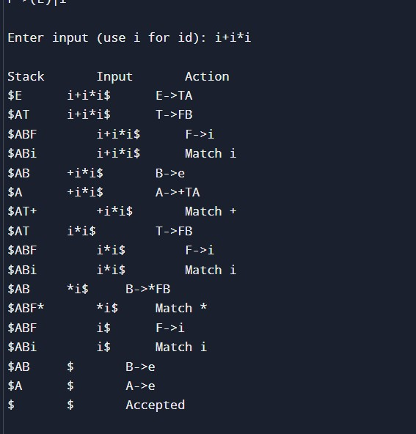
PROGRAM 2:
#include <stdio.h> #include <string.h>
char input[50], stack[50]; int top = -1, i = 0;
void printState(char action[]) { printf("%-15s %-15s %s\n", stack, input + i, action);
}
int main() {
printf("Grammar:\n"); printf("E -> E+E\n"); printf("E -> E*E\n"); printf("E -> i\n\n");
printf("Enter input (use i for id): "); scanf("%s", input);
strcat(input, "$");
printf("\n%-15s %-15s %s\n", "Stack", "Input", "Action");
while (1) {
// Shift stack[++top] = input[i++]; stack[top + 1] = '\0'; printState("Shift");
// Reduce i -> E if (top >= 0 && stack[top] == 'i') { stack[top] = 'E'; printState("Reduce E->i");
}
// Reduce E*E -> E (Higher precedence) while (top >= 2 && stack[top] == 'E' && stack[top - 1] == '*' &&
stack[top - 2] == 'E') {
top -= 2; stack[top] = 'E'; stack[top + 1] = '\0'; printState("Reduce E->E*E");
}
// Reduce E+E -> E while (top >= 2 && stack[top] == 'E' && stack[top - 1] == '+' && stack[top - 2] == 'E') {
// Delay reduction if next input is '*' if (input[i] == '*') break;
top -= 2; stack[top] = 'E'; stack[top + 1] = '\0'; printState("Reduce E->E+E");
}
// Accept if (strcmp(stack, "E") == 0 && input[i] == '$') { printState("Accept"); printf("\nString Accepted\n"); break;
}
if (input[i] == '$' && strcmp(stack, "E") != 0) { while (top >= 2 && stack[top] == 'E' && stack[top - 1] == '+' && stack[top - 2] == 'E') {
top -= 2; stack[top] = 'E'; stack[top + 1] = '\0'; printState("Reduce E->E+E");
}
if (strcmp(stack, "E") == 0) { printState("Accept"); printf("\nString Accepted\n");
} else { printf("\nString Rejected\n");
} break;
}
}
return 0;
}
OUTPUT:
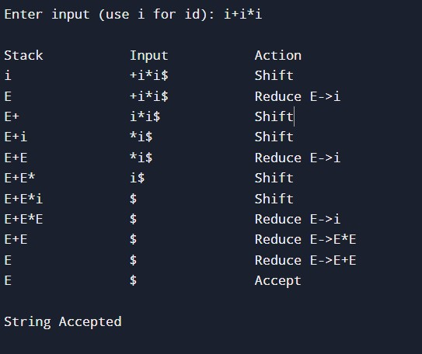
PROGRAM 3:
#include <stdio.h> #include <string.h> char input[100]; char stack[100]; int top = -1, ip = 0; void push(char x)
{ stack[++top] = x;
}
void pop()
{ top--;
}
void displayStack()
{ for (int i = 0; i <= top; i++) printf("%c", stack[i]);
}
int main()
{
printf("Grammar after removing Left Recursion:\n"); printf("S -> TA\n"); printf("A -> +TA | e\n"); printf("T -> FB\n"); printf("B -> *FB | e\n"); printf("F -> (S) | i\n\n");
printf("Enter input (use i for id): "); scanf("%s", input);
strcat(input, "$");
push('$'); push('S');
printf("\n%-15s %-15s %s\n", "Stack", "Input", "Action");
while (top >= 0)
{
displayStack(); printf("\t\t%s\t\t", input + ip);
char X = stack[top]; char a = input[ip];
// Accept if (X == '$' && a == '$')
{
printf("Accepted\n"); printf("\nString Accepted\n"); break;
}
// Match terminals if (X == 'i' || X == '+' || X == '*' || X == '(' || X == ')' || X == '$')
{ if (X == a)
{ pop(); ip++; printf("Match %c\n", a);
} else { printf("Error\n"); break;
}
}
// S -> TA else if (X == 'S')
{ if (a == 'i' || a == '(') { pop(); push('A'); push('T'); printf("S->TA\n");
} else { printf("Error\n"); break;
}
}
// A -> +TA | e else if (X == 'A')
{ if (a == '+') { pop(); push('A'); push('T'); push('+'); printf("A->+TA\n");
} else if (a == ')' || a == '$')
{ pop(); printf("A->e\n");
}
else { printf("Error\n"); break;
}
}
// T -> FB else if (X == 'T')
{ if (a == 'i' || a == '(') { pop(); push('B'); push('F'); printf("T->FB\n");
} else { printf("Error\n"); break;
}
}
// B -> *FB | e else if (X == 'B')
{ if (a == '*') {
pop(); push('B'); push('F'); push('*'); printf("B->*FB\n");
} else if (a == '+' || a == ')' || a == '$')
{ pop(); printf("B->e\n");
} else { printf("Error\n"); break;
}
}
// F -> i | (S) else if (X == 'F')
{ if (a == 'i') { pop(); push('i'); printf("F->i\n");
} else if (a == '(')
{
pop(); push(')'); push('S'); push('('); printf("F->(S)\n");
} else { printf("Error\n"); break;
}
}
}
return 0;
}
OUTPUT:
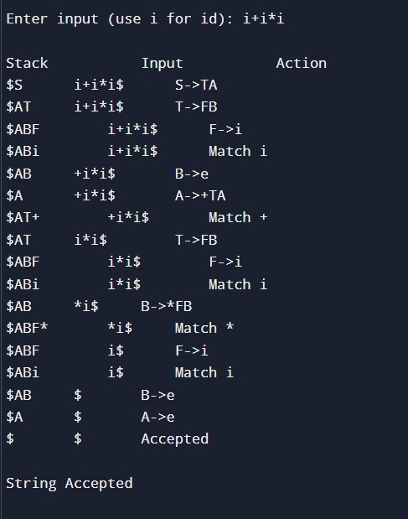
RUBRICS FOR CALCULATION:
Criteria | Weightage | Level 4 –  Exemplary | Level 3 – Proficient | Level 2 –  Developing | Level 1 – Beginning
Understanding of Concepts | 20 | Demonstrates thorough understandin g and integrates multiple concepts effectively | Good understandi ng with proper integration of most concepts | Basic understandi ng with partial integration | Poor understandi ng with no integration
Design & Implementati on | 25 | Welldesigned solution with | Correct design with minor | Basic design with errors or | Incorrect or incomplete design
 |  | systematic and optimal implementati on | issues | inefficienci es
Parser/Algorithm Construction | 20 | Accurate construction of parser/algorit hm with complete logic | Mostly correct constructio n with minor errors | Partial constructio n with missing logic | Incorrect or incomplete  constructio  n
Analysis & Validation | 15 | Insightful analysis with correct validation and justification | Good  analysis with reasonable justification | Basic analysis with limited validation | Poor or incorrect analysis
Documentation  &  Presentation | 20 | Wellstructured documentati on with diagrams, steps, and clarity | Organized documentat ion with required details | Basic documentat ion with missing details | Poor or incomplete documentat ion
Program4:

